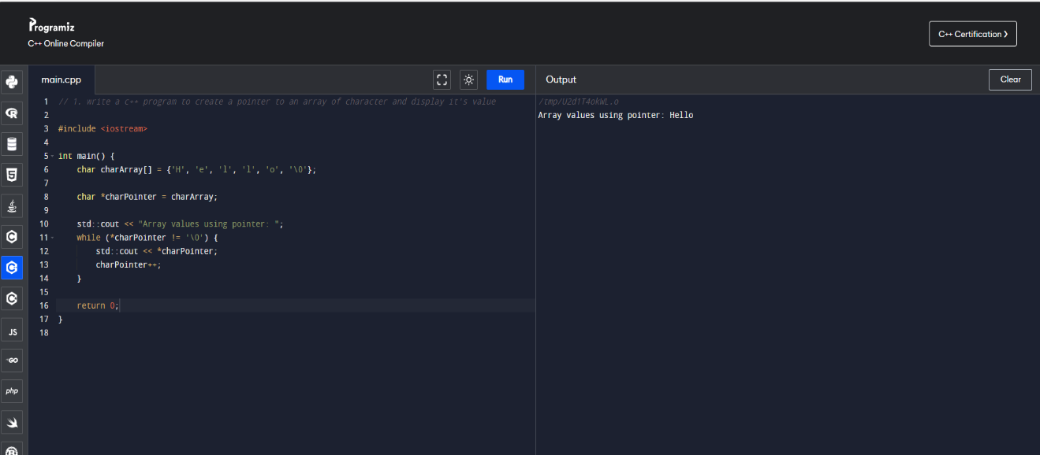

User

**You**

1. write a c++ program to create a pointer to an array of character and display it's value

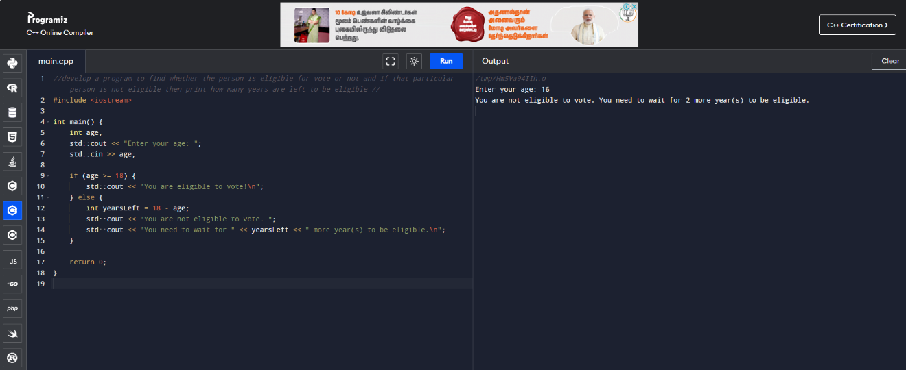

User

**You**

1. develop a program to find whether the person is eligible for vote or not and if that particular person is not eligible then print how many years are left to be eligible

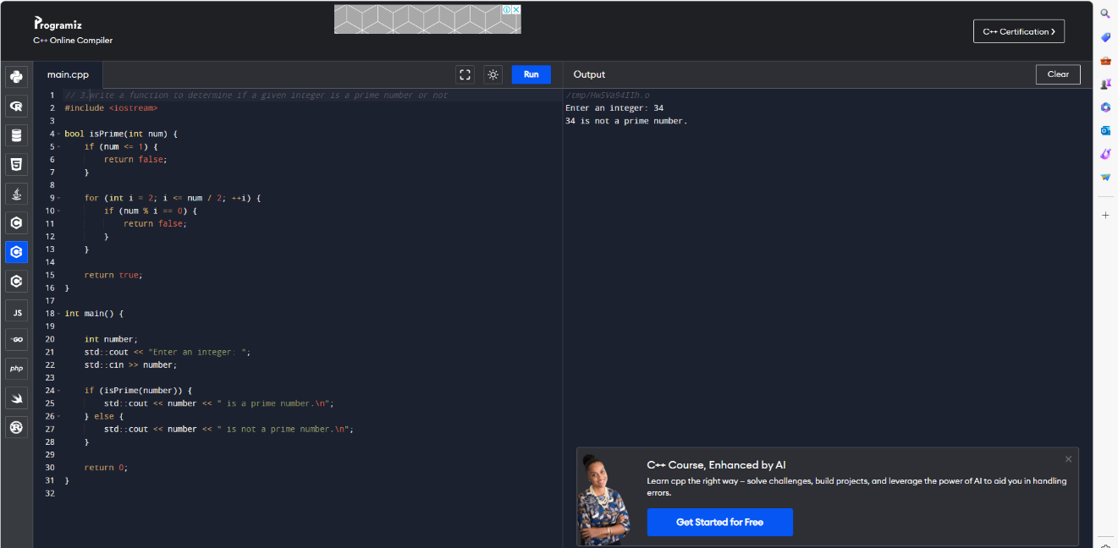

User

**You**

1. write a function to determine if a given integer is a prime number or not

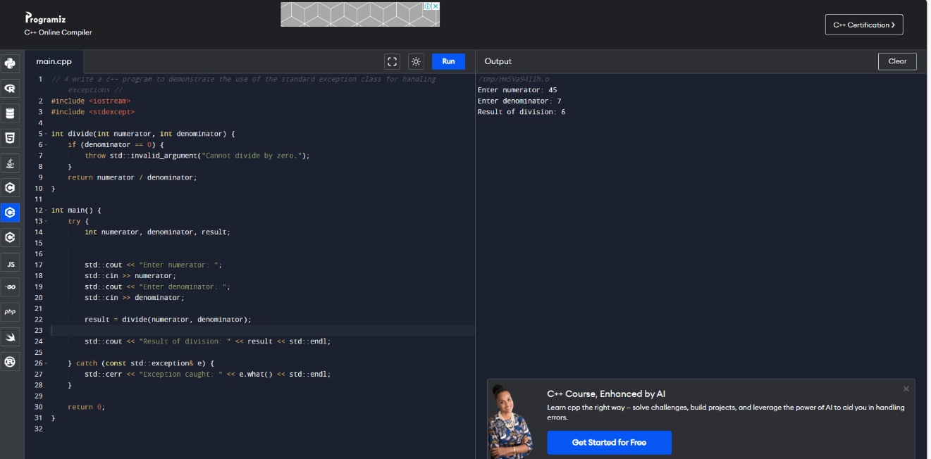

User

**You**

1. write a c++ program to demonstrate the use of the standard exception class for handling exceptions

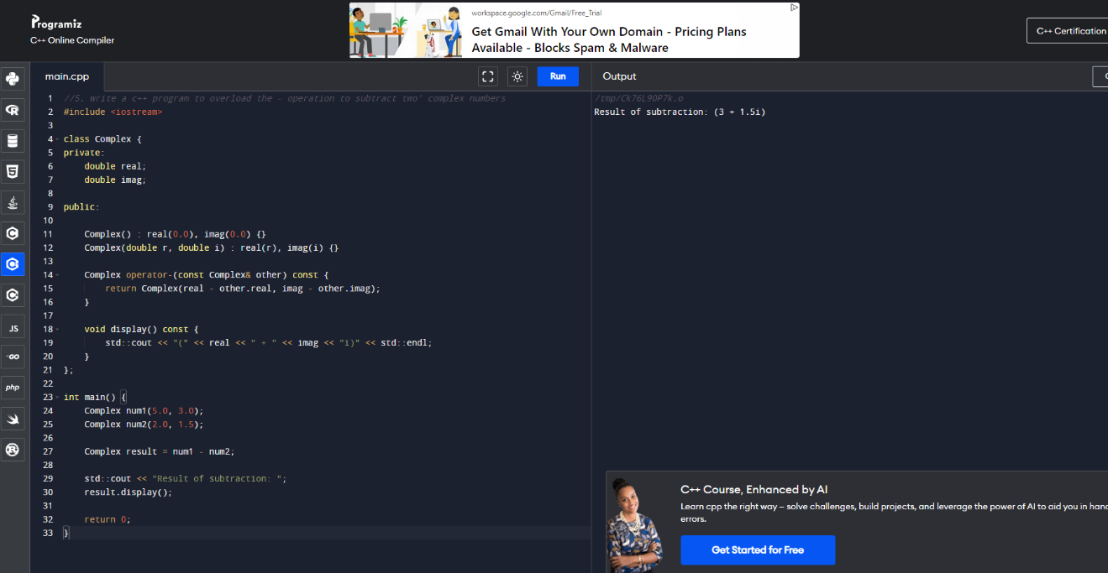

User

**You**

1. write a c++ program to overload the - operation to subtract two' complex numbers

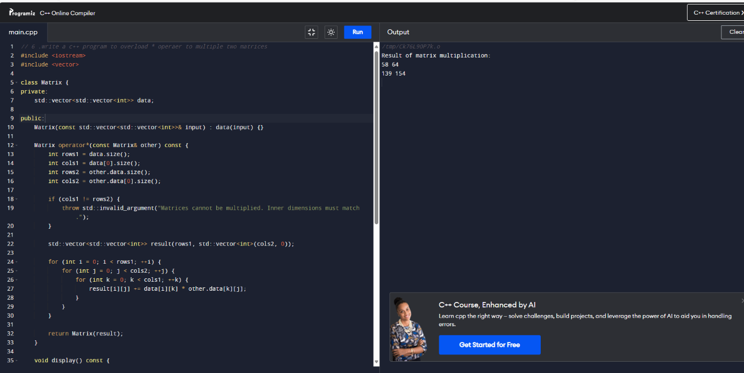User

**You**

1. write a c++ program to overload * operaer to multiple two matrices

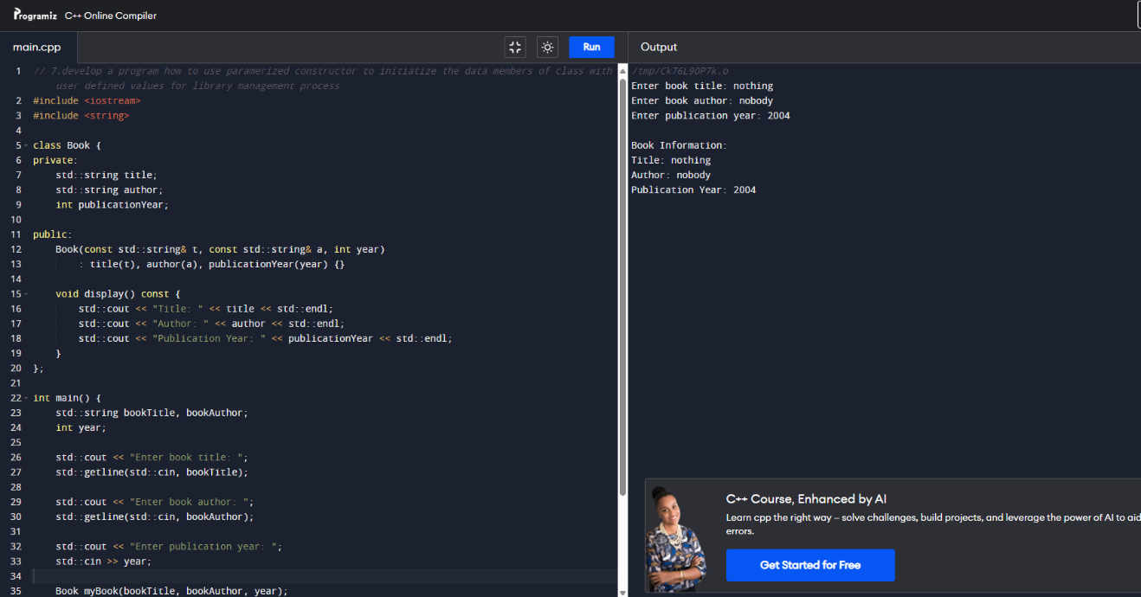User

**You**

1. develop a program how to use paramerized constructor to initiatize the data members of class with user defined values for library management process
2. getting the book details ( book id , Name)in stack
3. user details ( register number , name) in stack

1. check the availability of books in stack

4) distribute the book for user

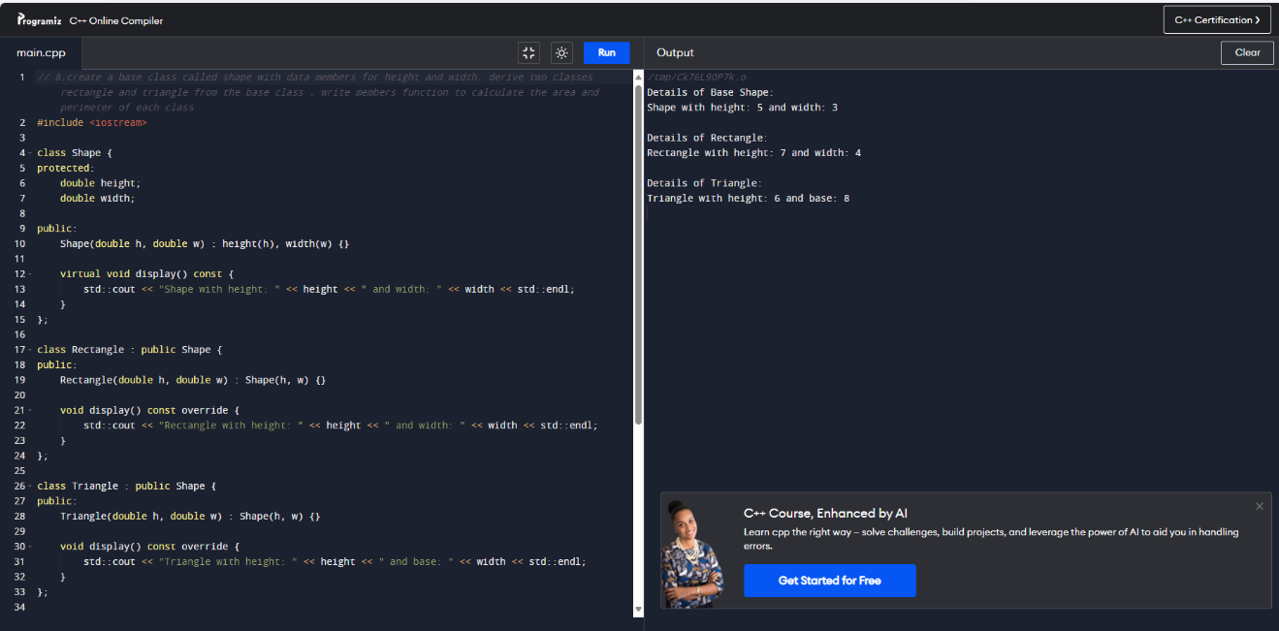

User

**You**

1. create a base class called shape with data members for height and width. derive two classes rectangle and triangle from the base class . write members function to calculate the area and perimeter of each class